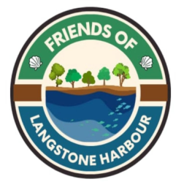
SUBSCRIPTION FORM

The 2026 annual subscription to join the Friends of Langstone Harbour
is £5 per person

Please complete:

Name:
Tel/Mob:
Email Address:

PAYMENT BY BACS (preferable)
Account Name: Friends of Langstone Harbour
Sort code: 30 93 97
Account Number: 21966760
Bank: Lloyds Bank HAVANT
Please quote your name as a reference
Please complete this form and email it to flhmembership@gmail.com

If you prefer to pay by cheque please contact flhmembership@gmail.com

All data will be held securely and GDPR compliant.
Data privacy policy available on request Sept 2026

